Amazon SNS
Simple Notification Service
Sending Email Notifications to Multiple Users

Objectives
By the end of this lab, you will be able to:
- Create an Amazon SNS Standard Topic for email-based notification delivery
- Add multiple email subscribers to a single SNS topic
- Confirm subscriptions via the email verification link sent by AWS SNS
- Publish a message to an SNS topic and deliver it simultaneously to all confirmed subscribers

Step 1: Create an SNS Standard Topic
Navigate to the AWS Management Console and search for "SNS" or go to Amazon SNS. Click on Topics in the left panel, then click Create topic.
Configure the topic as follows:
- Type: Standard
- Name: Testing-email
- Display name: Notification
Click Create topic to proceed.
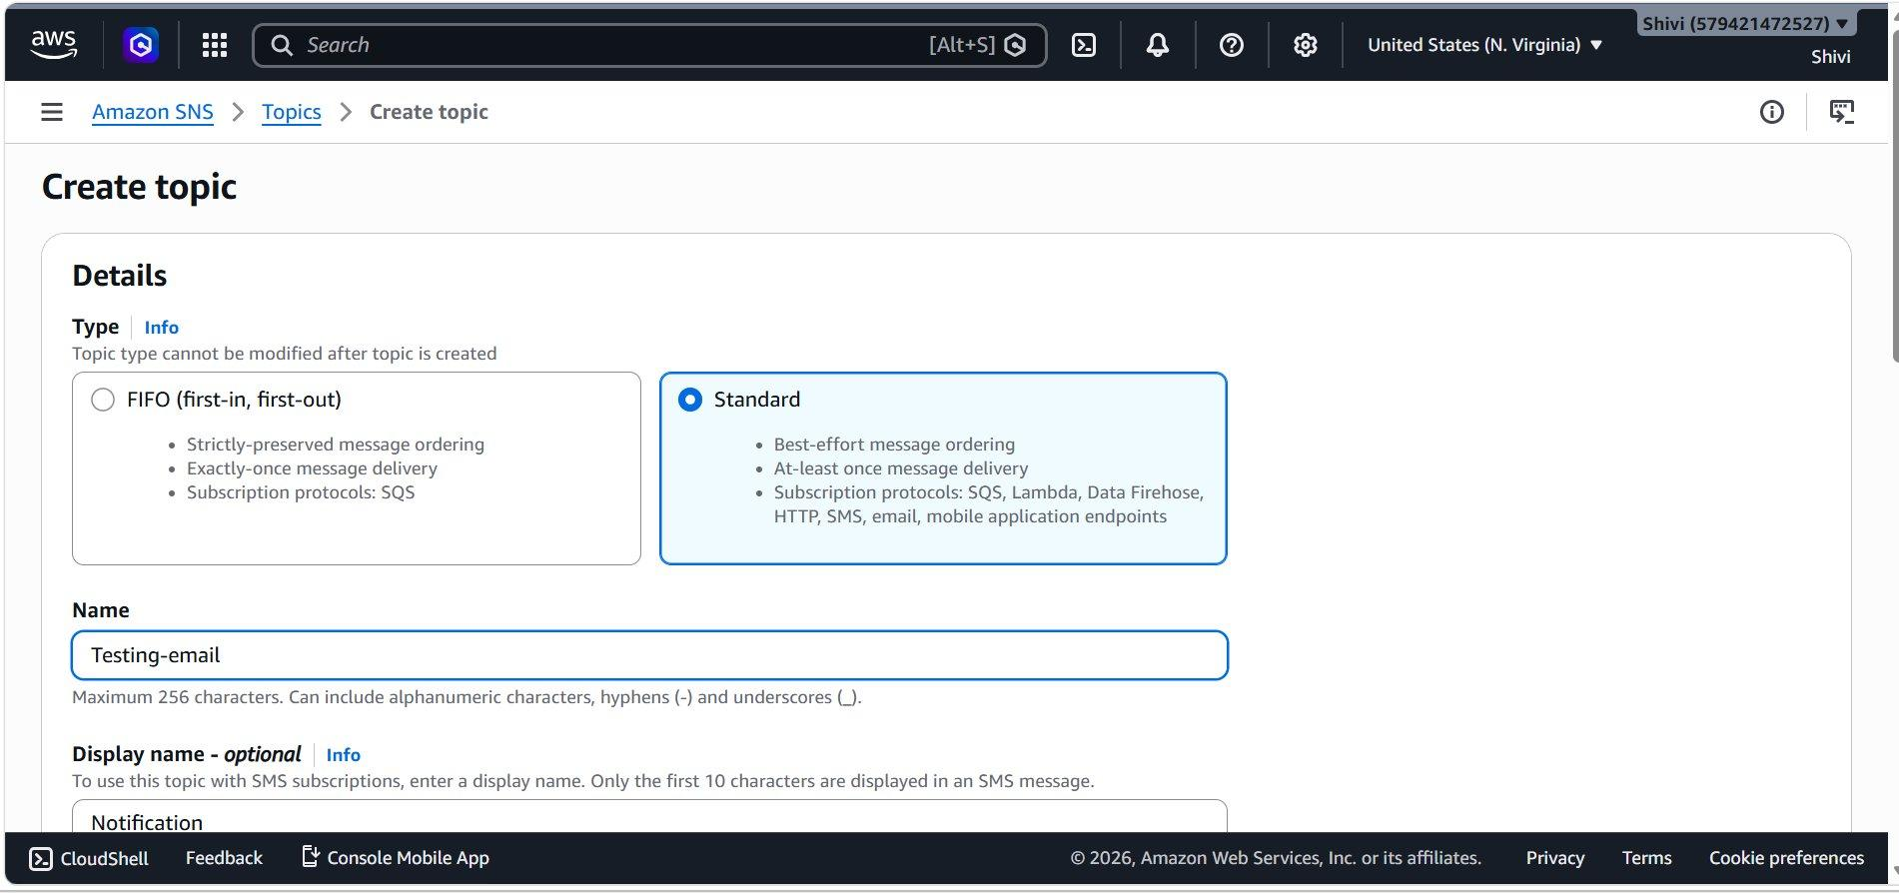

Step 2: Topic Created Successfully
After clicking Create topic, you will be redirected to the topic detail page. You should see a green success banner confirming the topic was created.
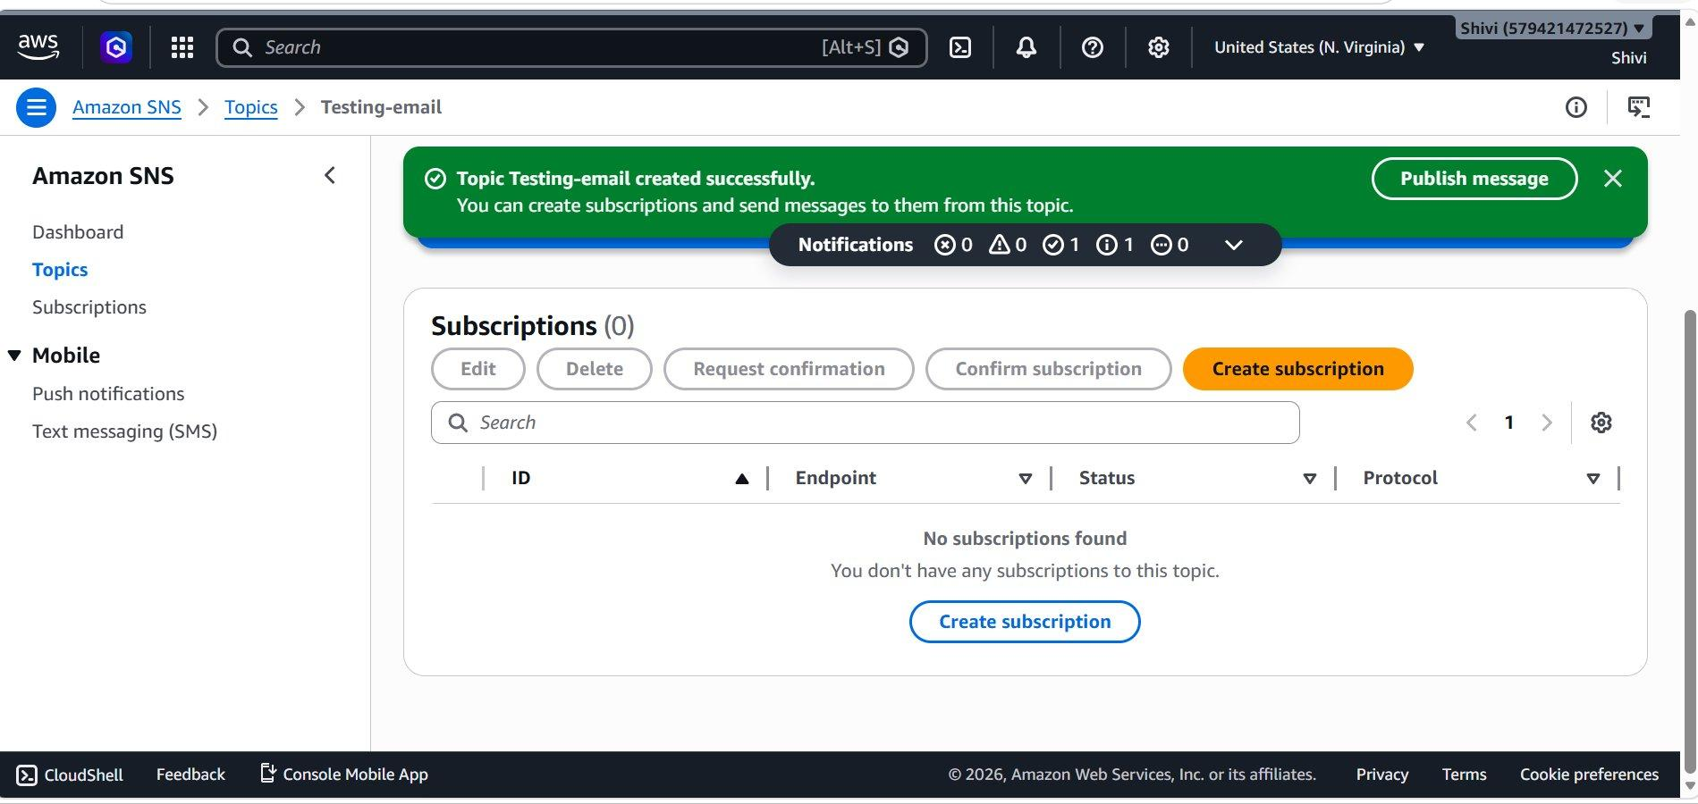

Step 3: Create the First Email Subscription
Click the orange Create subscription button. On the Create subscription page, configure the following:
- Protocol: Email
- Endpoint: (first subscriber email)
Note the blue information box: "After your subscription is created, you must confirm it." SNS sends a confirmation email to the address — the subscriber must click the link to activate.
Click Create subscription.
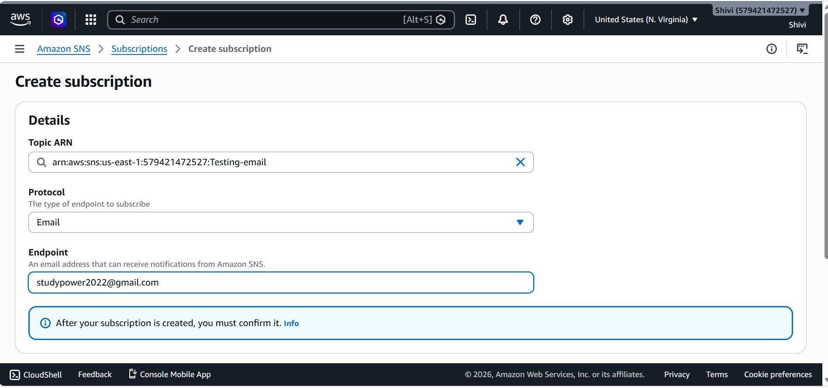

Step 4: First Subscription Created
A green banner confirms the subscription was created.
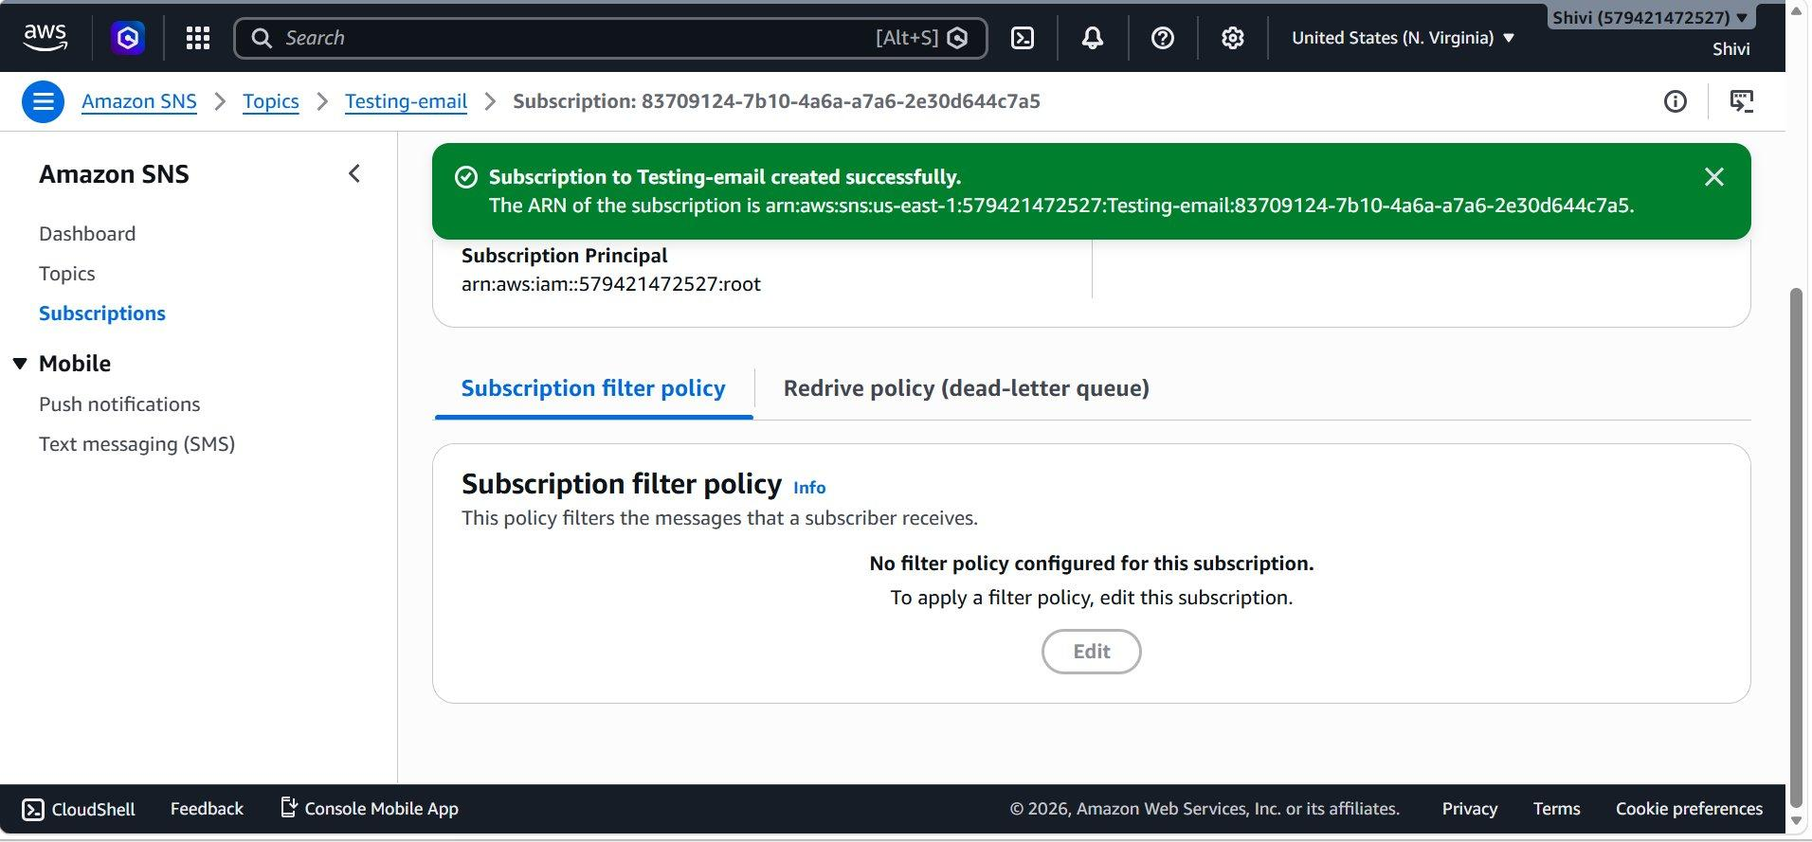

Step 5: Confirm First Subscription via Email
AWS sends a confirmation email to the subscriber with a "Confirm subscription" link. The subscriber must open this email and click the link. Upon clicking, they are taken to the AWS SNS confirmation page shown below:
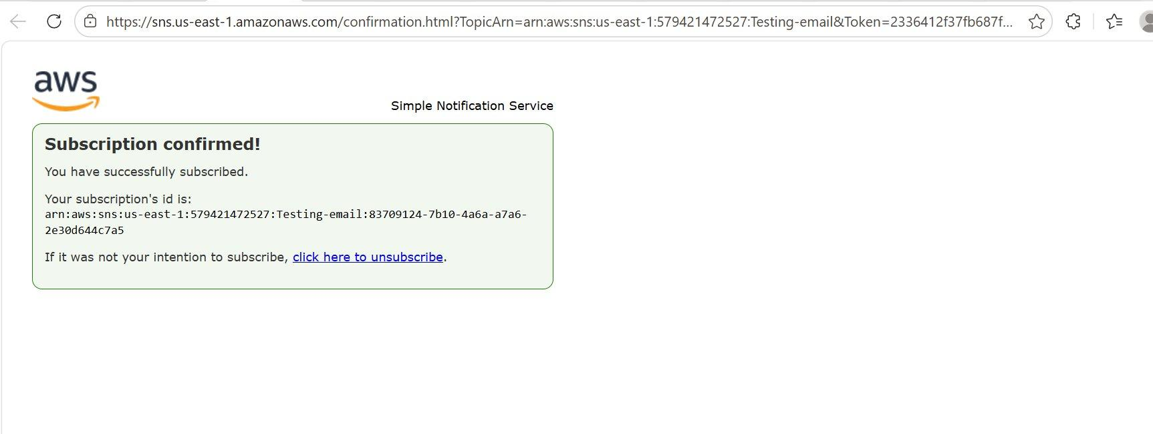

Step 6: Verify First Subscription is Confirmed
Return to the AWS SNS Console → Subscriptions. The status for the first subsccription now shows "Confirmed" in green, meaning this will receive all future messages published to the Testing-email topic.
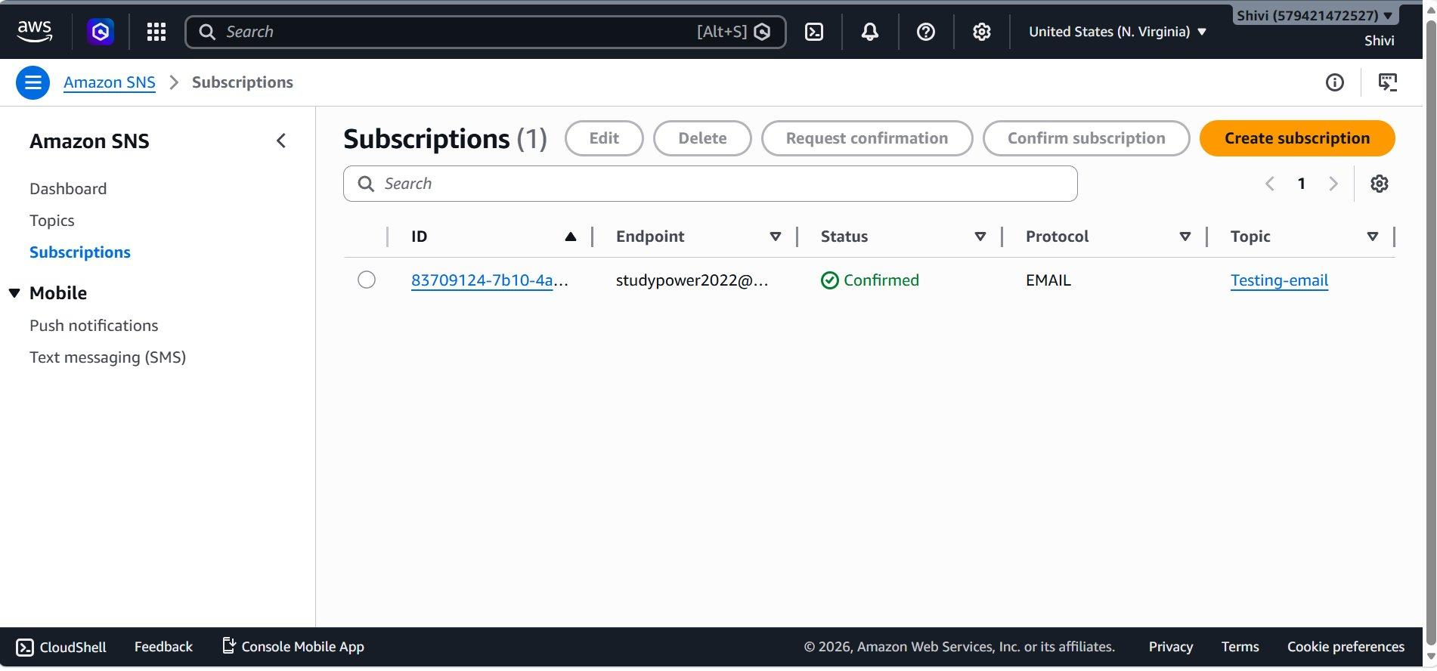

Step 7: Add a Second Email Subscriber
Click Create subscription again to add a second subscriber. Configure the same Topic and Email protocol, but with a different endpoint:
- Protocol: Email
- Endpoint: (second subscriber)
Click Create subscription.
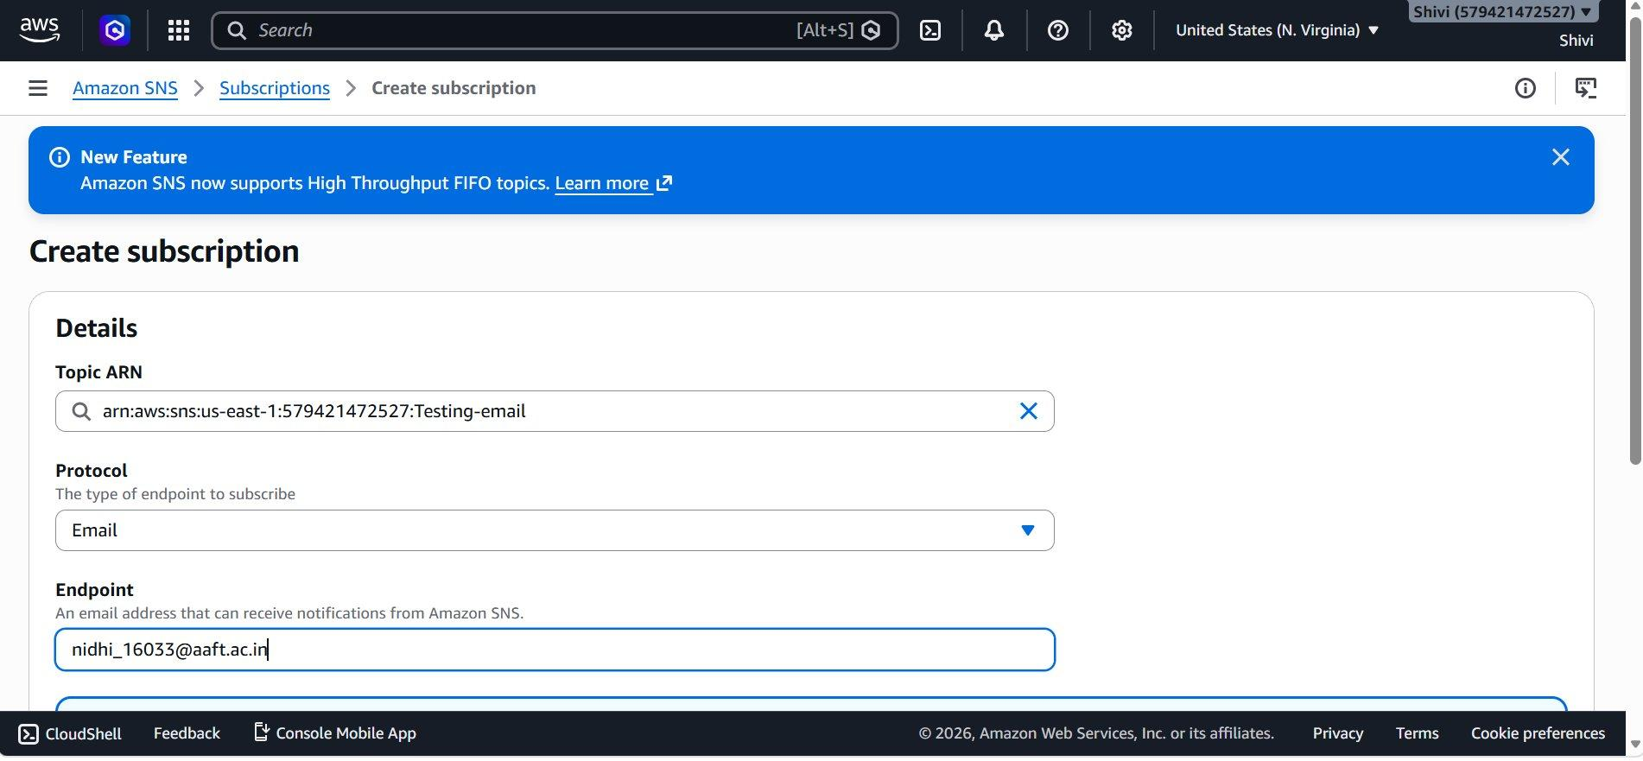

Step 8: Second Subscription Created — Pending Confirmation
The second subscription is created. You can see status "Pending confirmation". The second subscriber must now confirm via their email inbox.
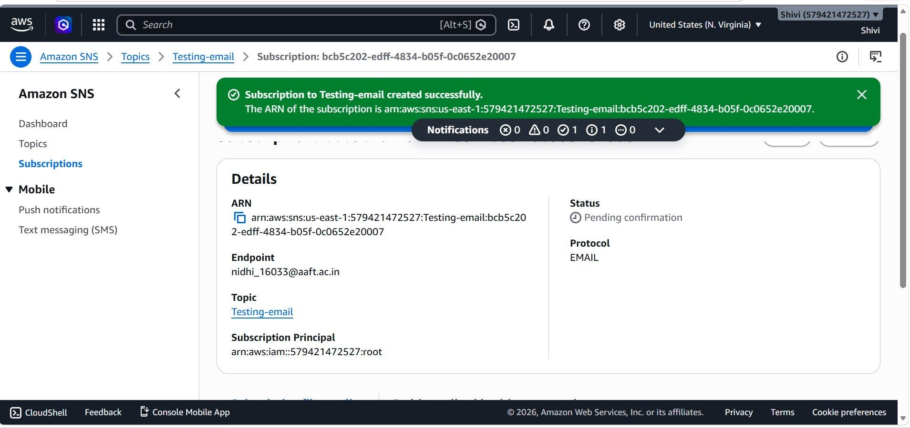

Step 9: Second Subscriber Confirms the Subscription
The second subscriber receives a confirmation email from AWS SNS. They click the link and are shown the confirmation page .
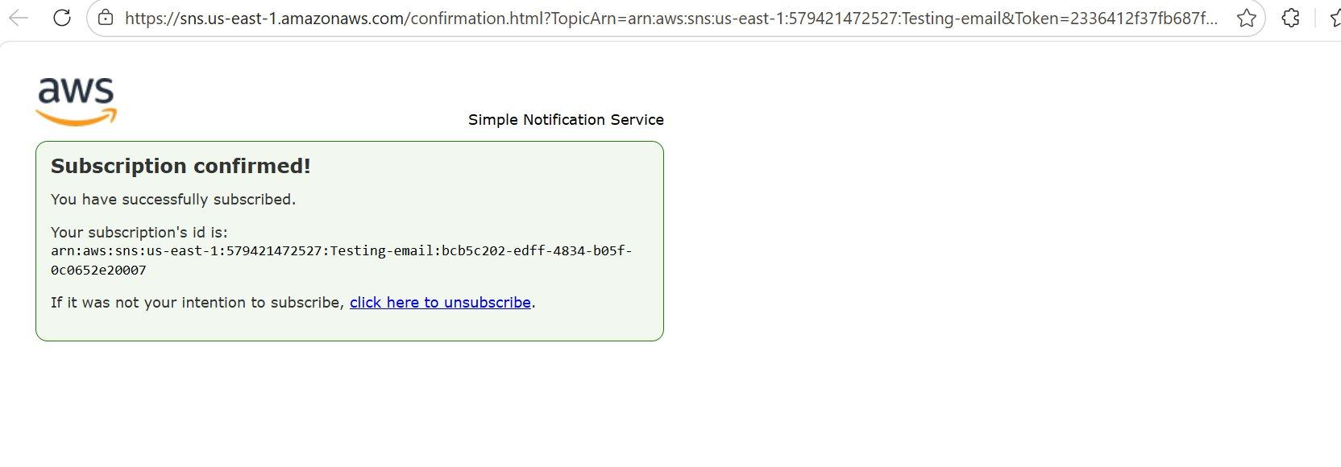

Step 10: Publish a Message to the Topic
Navigate back to the Testing-email topic and click Publish message. On the Publish message page, fill in:
- Subject :Testing-email-AWS
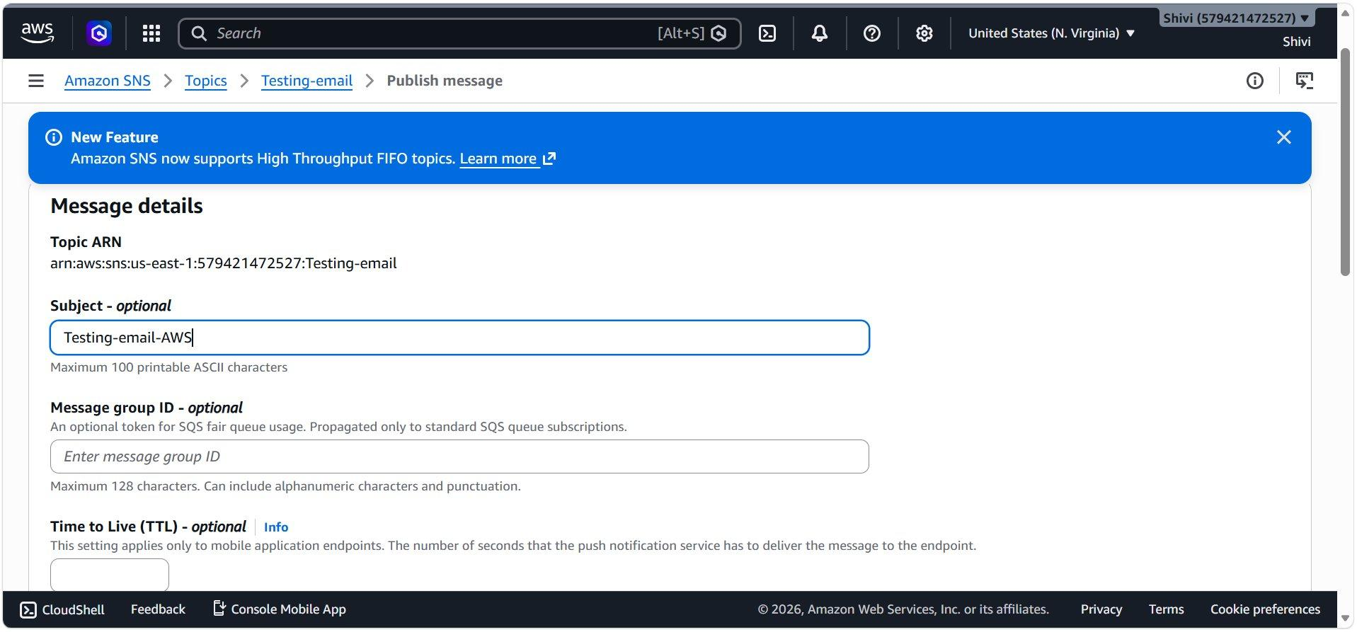

Step 11: Configure the Message Body
Scroll down to the Message body section:
- Message structure: Identical payload for all delivery protocols
- Message body to send: Hello AWS
Click Publish message to send to all confirmed subscribers.
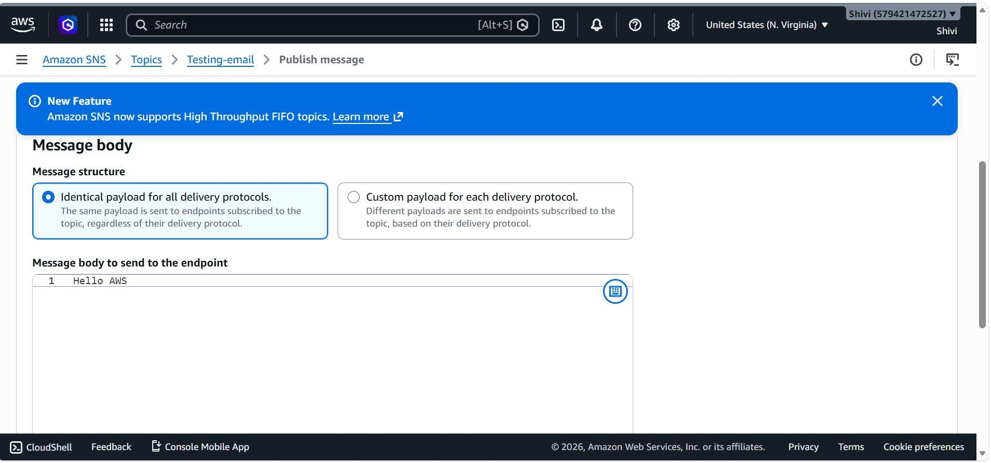

Step 12: Message Published — Delivered to Both Subscribers
A green success banner confirms the message was published to the Testing-email topic. The console shows both subscriptions with "Confirmed" status — both email addresses will receive the "Hello AWS" email with subject "Testing-email-AWS".
